Spring Budding Moon
Monthly Newsletter: March 5th – April 3rd 2011
from the Gila Circle Way Project:
“learning to live with our relatives”

Outdoor skills, naturalist and indigenous studies, youth adventures and camps, community gatherings….bringing us together through appreciation of wild nature and music!

The Gila Circle Way Project is a new local southwest New Mexico organization aimed at helping local community members learn more about and interact more meaningfully with the wild natural world surrounding us, and with our local human community. Through outdoor programs for kids (after-school programs, home-school groups, camping and backpacking trips), earth skills workshops and nature walks for all ages, African drumming classes for kids and adults, wilderness summer camps, full-moon drumming and dance gatherings, Wild Harvest Campouts, craft nights, and many other activities, we provide a format for consistent and quality interactions with nature and with each other for local kids and adults.

Spring Budding Moon!
What a beautiful feeling it is to feel the warmth of the sun begin to push through strongly again as spring comes around the bend and greets us again. The robins have been singing steadily in the mornings, calling back and forth to each other from the cottonwoods. The willows are starting to bud, and we can watch many other plants and trees do the same as this moon grows full and shrinks back down again in early April. Time to kick off your shoes and go barefoot once again!

~~~~~~~~~~~~~~~~~~~~~~~~~~~~~~~~~~~~~~~~~~~~~~~~~~~~~~~~~~~~~~~~~~~~~~~~~~~~~~~~~~~
Our Wednesdays “Wild Neighbors Walkabout” Group

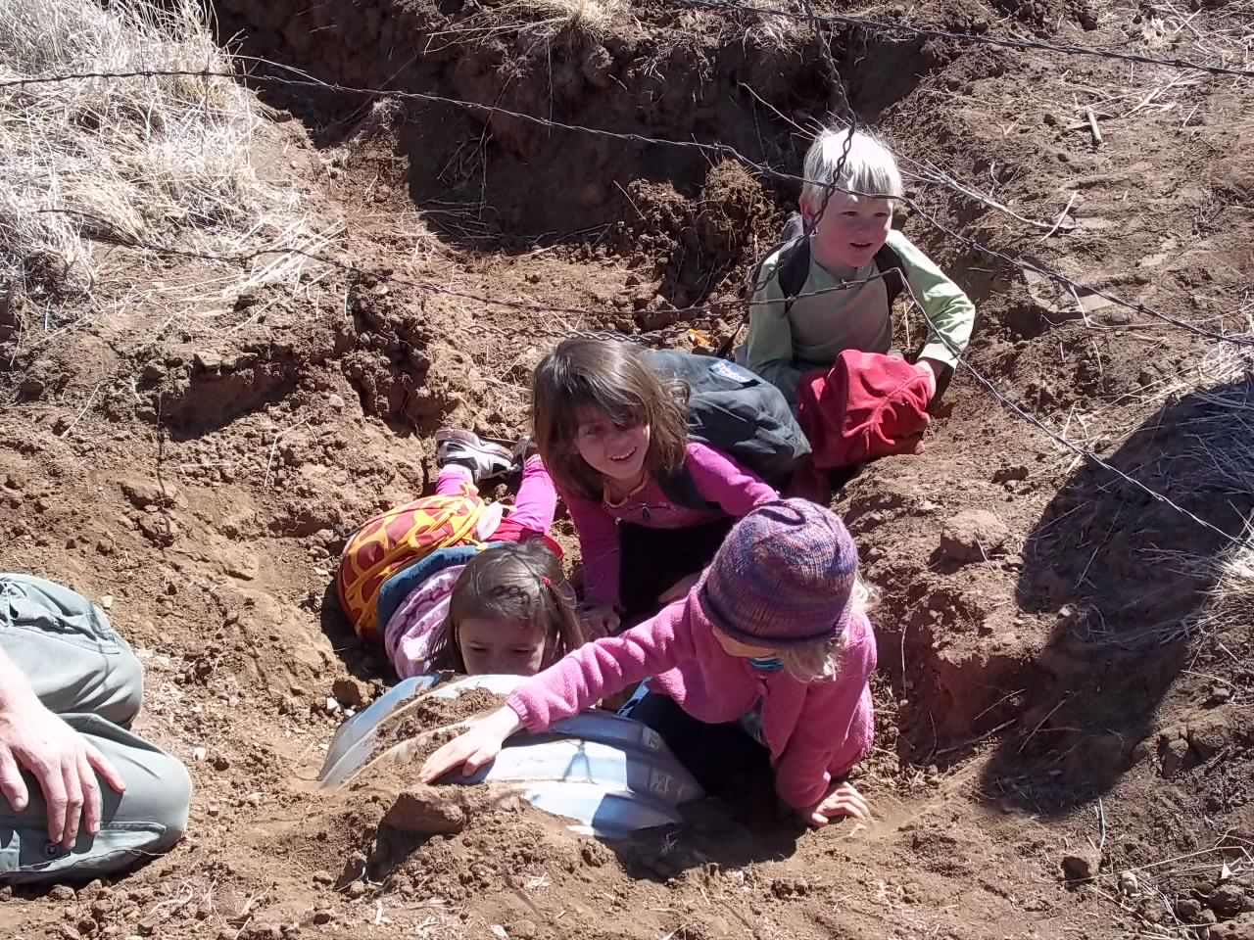
Every Wednesday for the past 6 months now, our Circle Way group of 9 kids has been meeting and heading out into the wild (-ish) places in and around Silver City to get dirty, hear stories, sit around a fire, wander and explore the outdoors, learn to move silently in the woods, wake up their senses, be outside, make crafts and learn Old Way earth skills, and have fun! What a necessary and wonderfully fulfilling time together! We’ve been loving every moment of it, getting to know our surroundings and each other out on the belly of the earth, where we belong!

The Gila Circle Way Project
1104 W. 7th St.
Silver City, NM 88061
Phone: (575)519-9232 Email: info@gilacirclewayproject.org
Current Happenings with the Circle Way Project:

We’re back at it working on the new wigwam/wickiup out on Mountain View Rd. What is a wigwam or wickiup? It’s a domed lodge covered with bark, thatching material, or brush. This kind of shelter is common to some of the native peoples of the Southwest, as well as many nature-based peoples around North America and the world. We plan to finish this shelter, thatched with local Beargrass (Nolina Microcarpa), and have a beautiful space close to town to use for traditional skills workshops, community gatherings, as well as a possible seasonal living space. Liam Evans, a student at Aldo Leopold High School is currently interning with the Gila Circle Way Project, and helping the wigwam project move along toward its beautiful finish. If anyone is interested in seeing and learning more about the project, and more importantly, helping out with it ( ☺ ), you are more than welcome. Give us a call at 519-9232.

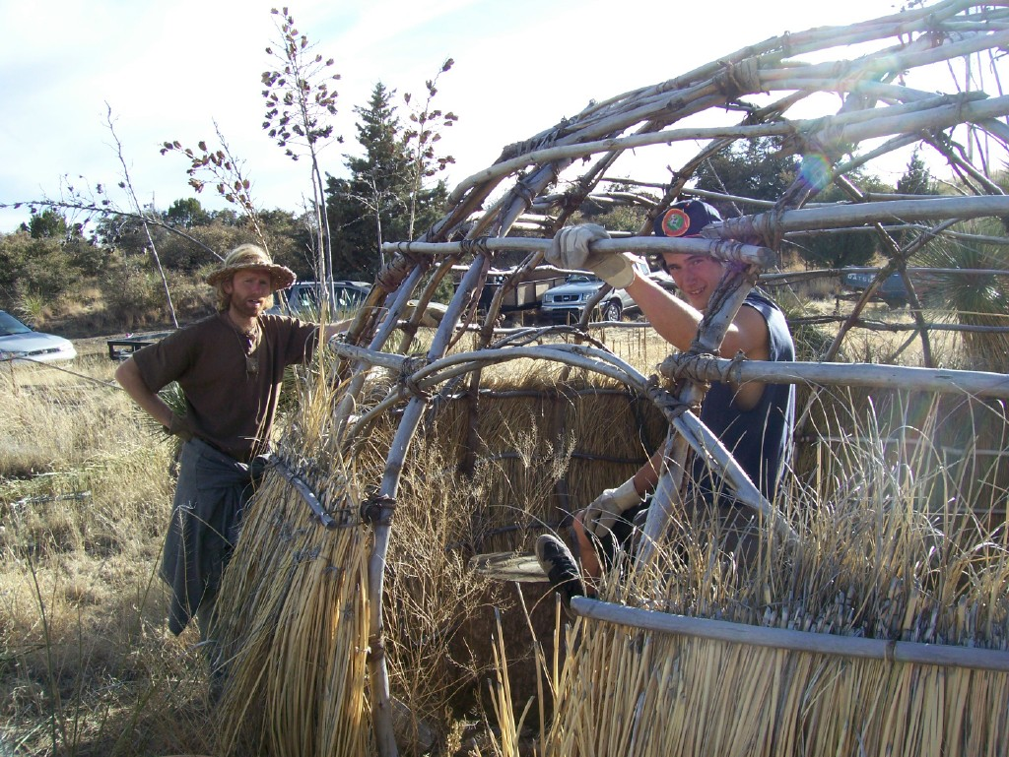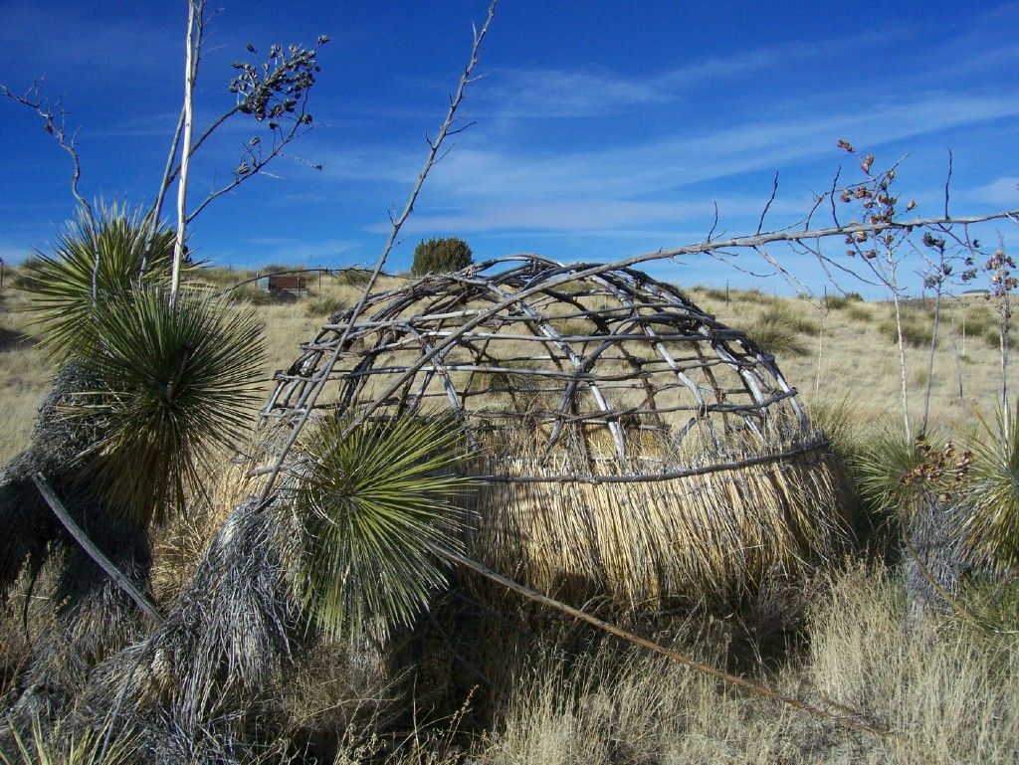
Andrew and Liam working on the wigwam in progress beneath the brilliant NM sky

Coming soon: Wilderness Club for teenagers ~ Explore the outdoors, learn more about the plants and animals in our area, learn indigenous skills useful in the natural world
~~~~~~~~~~~~~~~~~~~~~~~~~~~~~~~~~~~~~~~~~~~~~~~~~~~~~~~~~~~~~~~~
We have a pretty nice little library of books related to the study of nature, native skills and lifeways, communication, communal living, many good field guides, tracking books, etc. You are welcome to come and see our selection and borrow a book for your own study.
~~~~~~~~~~~~~~~~~~~~~~~~~~~~~~~~~~~~~~~~~~~~~~~~~~~~~~
For those interested in West-African Drumming Classes, we will start a new beginner’s class on March 17th Call 519-9232 to sign-up

~ Kids classes also available, depending on interest ~
And those interested in a Capoeira group, call us!

~ Find us on the web at www.gilacirclewayproject.org ~
Coming next month:
* House Concert for Andrew’s new CD ~ April 8th or 9th
* Firemaking Workshop: learn to make fire as your ancestors did ~ April 16th
* Full-Moon Community “African Squaredance” ~ April 17th
* Plant Walk with Doug Simons ~ April 23rd
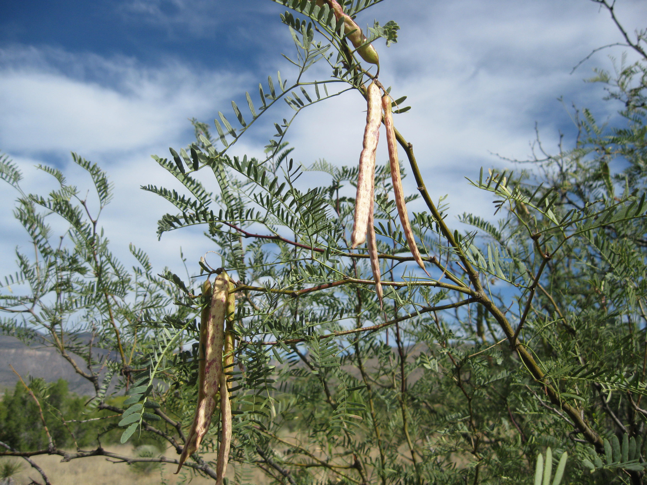
edible, delicious mesquite pods

Nature as Culture by Andrew Dahl-Bredine
What manner of wisdom do we lack as a society, as a culture, that keeps us from achieving a good balance -- with our families, friends and neighbors, with our natural environment, and with our own heart-of-hearts? Where can we look for a more integrative model, for a source of wisdom and knowledge that doesn’t seem so subjective, so exclusively personal and difficult to share?
The place to look is the same it has been for humans for tens of thousands of years: it is the earth, in its wild and undomesticated state. For we are, after all, earthlings, in the truest sense. We are of this place, and this place has an order that applies to humans as well as all other creatures on this planet. That order is still in place, though we don’t even know it exists. And it is just beginning to dawn on us that we are not exempt; that we too must find a way to live as part of that great and sacred order; not just for the sake of the earth and its creatures, but for ourselves as human beings, whose secret of wholeness lies within the natural order of the earth. To defy that order is to cut ourselves off from the very source that sustains us; a source of wisdom still overflowing with the missing pieces to the puzzles of social stability, individual wholeness, purpose in life, communication, spiritual connection, sustainability, and physical health. It is the place to which successful human cultures have always looked as a source and basis for culture. Our immense task is to uncover what we have buried; to become aware of our tremendous blind spots that keep us from seeing what truly is, and how to take part in it.
We have grown up in a human-created world; one that values first and foremost human ideas, human creativity, human culture, and human history. We know that nature exists, but it has come (probably mostly unconsciously) to mean something pretty to look at or enjoy from time-to-time after our other plans, needs, desires, and responsibilities in the human-created world have been completed. As crazy as it may sound, the truth is that most of us don’t even really see nature, even when we are looking right at it.
To illustrate my point, I will share this story from well-known naturalist and environmental educator Jon Young’s book Kamana. Jon talks about another strange scientific study done a number of years ago in which newborn kittens were kept continuously in two separate white rooms. They were supposedly treated well, played with, fed, etc, and there was only one difference between the two rooms: in one room, there were black horizontal lines painted on the walls, and in the other, there were black vertical lines on the walls. The rest of both rooms were white and empty. At a certain point, all of the kittens were taken into a third white room, this one with a couple of chairs in it. What the researchers noticed is that the kittens who grew up in the room with horizontal black lines on the walls and no vertical lines would run right into the vertical legs of the chairs as if they literally could not see them! They would not run into the horizontal bars connecting the legs on the chairs. The kittens who had grown up in the room with the vertical lines on the walls but no horizontal ones would crash right into the horizontal cross-bars of the chair legs, but not the vertical legs! Now, it is not that their vision was impaired, for they eventually all learned to see and avoid both the horizontal and the vertical legs and crossbars of the chairs. What had happened was that their limited sensory input in their early experience of the world had created a sort of cultural blind spot that affected greatly what they were able to perceive.
Humans are no different than the kittens in this study, except that we seem to be even more affected and shaped by our cultural conditioning and cultural environment than most other species, cats included. In fact, we go around talking to ourselves inside our heads all day long, telling ourselves what the world is and isn’t, literally creating our own reality. Our potential for being blind to our sensory input and the actual world around us is staggering. And the sad reality we have created and inherited as 21st century westerners is one where we stand outside of creation; outside of the beautiful and mysterious order of life on Earth, since we are the exempt “humans,” and no longer also earthlings. Our collective cultural blindness to the earth’s teachings and mysteries, which have always been the main source of inspiration, understanding, knowledge of self and other, and how to live on this earth, is so strong that most of us don’t even know its there. We don’t know that there’s something we don’t see. And what we don’t see, we don’t get to be a part of. And to miss out on being a part of the great web of life, the dream of the earth, is what is killing us, from the inside out. This great separation from our place in the world in turn allows us to continue as a culture to destroy the very organism, our Mother Earth, who sustains us.
Nature as the basis of culture is something that successful human communities across the planet and throughout time have always had in common. The cycles of celestial bodies, seasonal changes, animal habits and movements, availability of food, sustaining capacities and capabilities of one’s particular ecosystem, and connection to a specific place, have always helped humans pattern out how they should live in accordance with what is. Our innate human ability to communicate with other non-human life forms, to literally listen to the land, is another piece of our wholeness that falls now into our collective cultural blindspot. It is a casualty of the worldwide conquest by the rational, intellectual, and individually-oriented part of our humanness; that which now reigns supreme and claims exclusive ownership of our access to truth and knowledge.
Saxton Pope was an American who became friends with Ishi, the last of the Yahi people (a native Californian tribe) to be swallowed up by Civilization in 1911. Perhaps he best put into words this primary difference in ways of knowing between our culture and that of a person of a nature-based culture when he said of Ishi, “He looked upon us as sophisticated children: smart, but not wise. We knew many things, and much that false. He knew nature, which is always true.”
And from those cultures who patterned their lives and cultures in accordance with the ways of the natural world, we can also learn about successful models of social organization, child rearing, group dynamics and communication, governance, and many more elements of healthy human life from these time-tested examples. We need these examples, now more than ever, as we watch our social fabric decay into isolation, abuse, addictions, depression, and disconnectedness. The earth still waits, holding the key to our humanness.
To step outside again, outside of our human-created world, to begin to learn about what truly is, is our task. We must become again like children, and, as David Abrams says, “break free from the Cult of Expertise,” with all the useless things we “know.” We must have the courage to admit that we don’t know which animals pass through our backyards at night; that we don’t know which plants we can eat, or what it means when the wind blows from the north. We don’t even know that the same bird perches on the tree by our car every morning without us even noticing her. This beautiful place we live is alive and full of secrets; secrets we need to know in order to find out who we are, and who we could be. In terms of true, first-hand, authentic knowledge of the place we live, we are truly like toddlers, with an endless amount yet to learn about the animals and the plants, the water, the trees, the stones, and the wonderful and unfathomable interconnectedness of it all. And ultimately, maybe even the grand question of where we fit into the beautiful living drama of life on Earth.
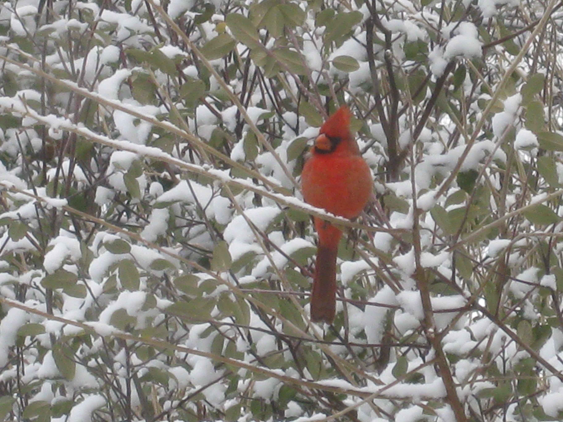
This Month’s Events
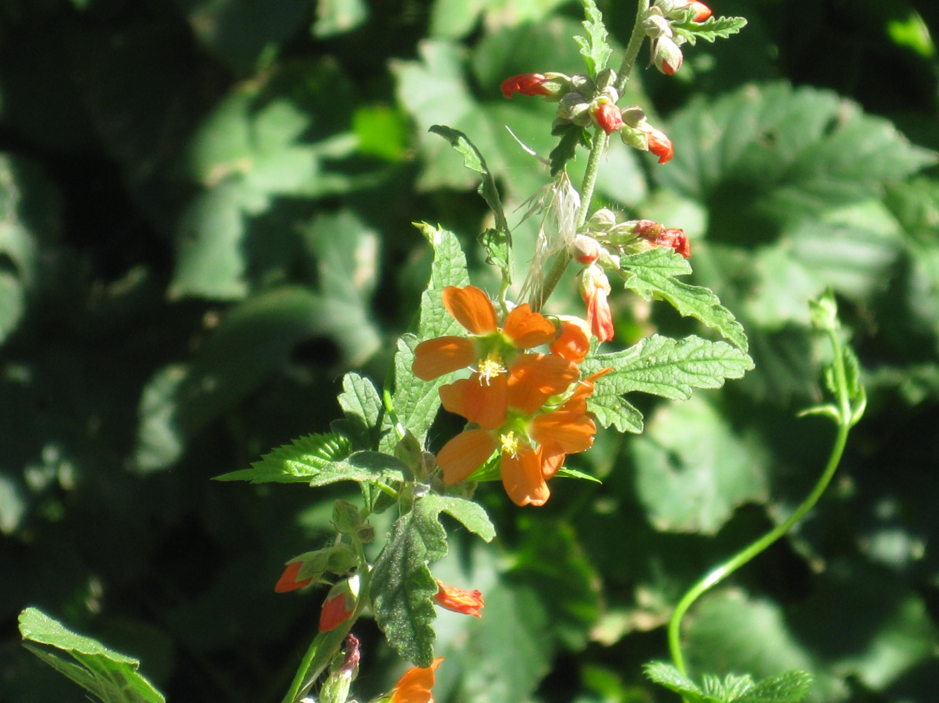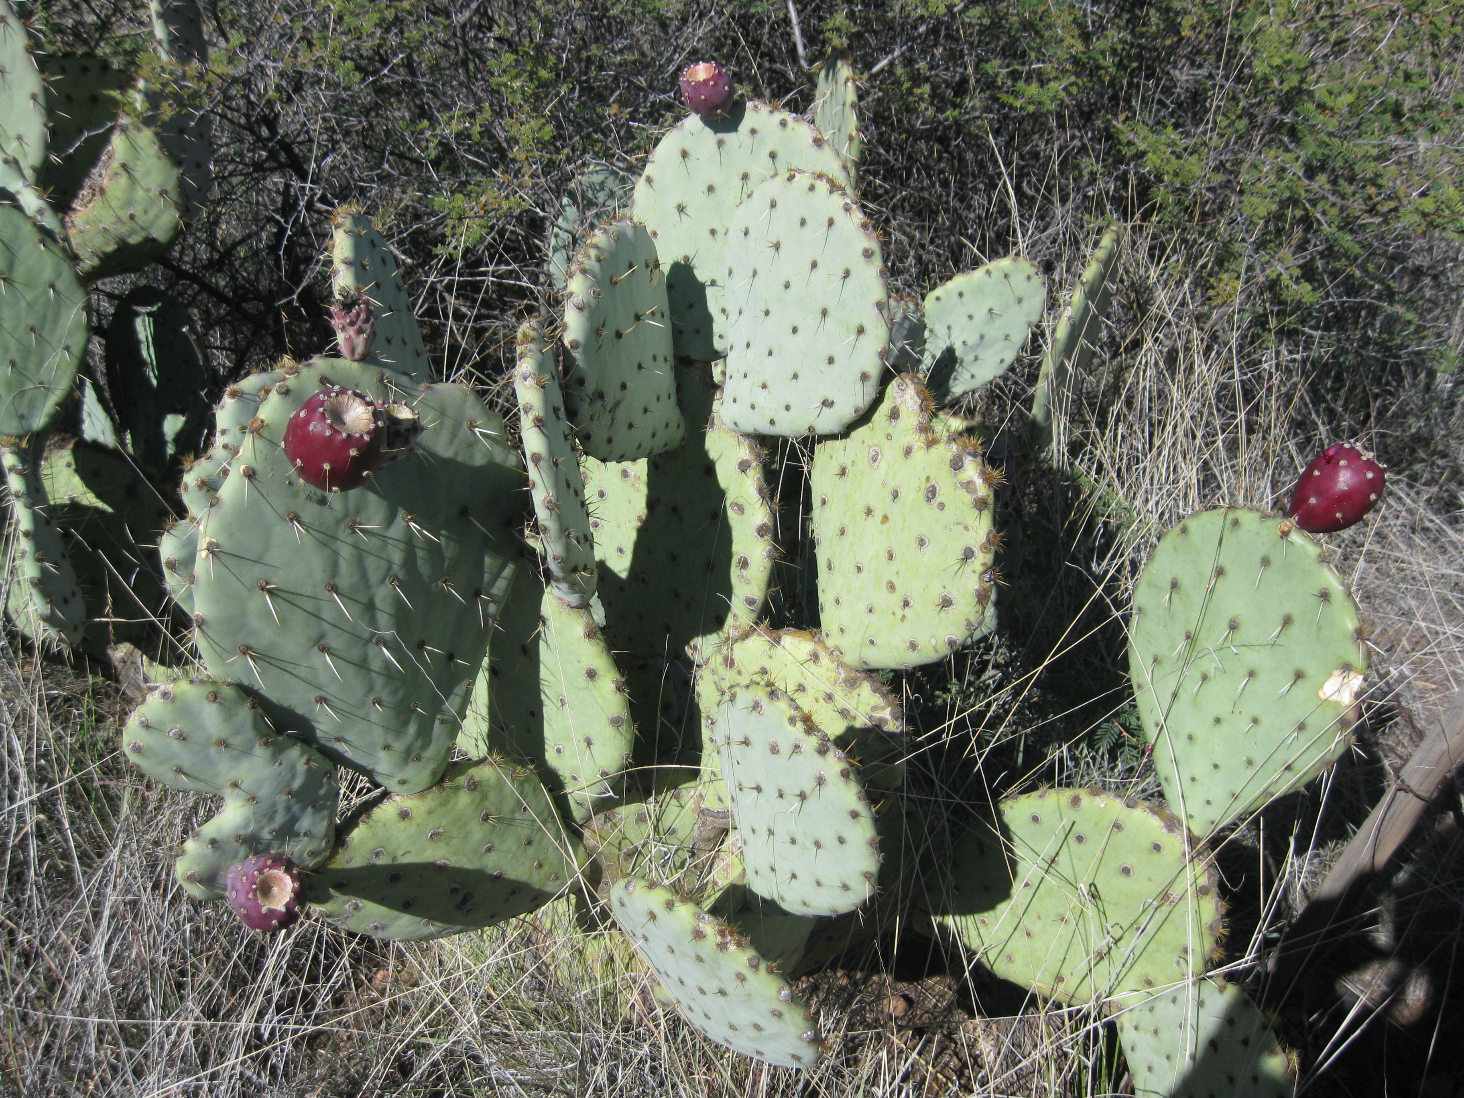
mallow prickly pear
Edible and Medicinal Plants of
Silver City’s Surrounding Hills
A Plant Walk with Doug Simons

Saturday, March 12th 9:30am – 12:30pm

Meet and learn to identify many local wild plants that can help heal and nourish you. Experience a deeper way of connecting to the plants and ways of opening the pathways of communication with them. Part of a monthly local plant walk series with Doug. A great time of year to see the new little ones coming up!

Doug’s 20+ years living in the wilderness areas of the Gila have blessed him with the unique and profound gift of meaningful relationships with the local plant community. His deep, first-hand knowledge and understanding of natural healing and local plants combined with his generous and personable way of sharing inspires us and reminds us of our innate human ability to connect with and understand the natural world around us.

Meet at the Boston Hill Market St. Trailhead. To get there, go West on Market St until it begins heading out of town up “Snake Hill,” toward Hwy 180 W. Just before the junction with 180, there is a pull-off and a well-marked trailhead on your left. See you there!
Cost is $25/person. To sign-up, or for more information, visit www.gilacirclewayproject.org
You can also call (575)519-9232 or email andrew21@wildmail.com
---------------------------------------------------------------------------------
Natural Tooth Care
and
How to Treat Tooth Problems Without a Dentist
A Natural Medicine Talk/ Workshop
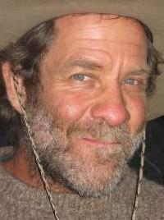
with Doug Simons

Friday, March 18th from
6pm – 9pm
at 1104 W. 7th St. in Silver City
Join us as well-known herbalist and medicine person Doug Simons shares his insight into the world of Natural Tooth Care. In this day, the care of our teeth is often handed over entirely to the dental professionals. More and more, we find that many of the accepted dental practices, such as root canals, implants, etc, can have very negative health consequences, not only for our teeth, but for our entire systems. Doug’s unique knowledge and angle on tooth care, based on decades of experience in this area, will provide you with a rare opportunity for empowerment in the health of your own teeth.

Topics to be covered will include:
~ Effective dental hygiene without brushes, paste, or floss ~
~ Treating cavities with herbs ~
~ Treating abscesses with herbs and poultices ~
~ Treating cracked and chipped teeth ~
~ Treating gums and gum disease ~

Cost is $25 per person.
You can register in advance at www.gilacirclewayproject.org,
For more information, call Andrew at (575) 519-9232

Class will be held at 1104 W. 7th St. in Silver City, near the corner of 7th and C St.
---------------------------------------------------------------------------------

Full Moon Community Dance to the Drums of West Africa
Sunday, March 20th at 12:00 noon
at the Big Ditch Park, just below the S.C. Food Co-op
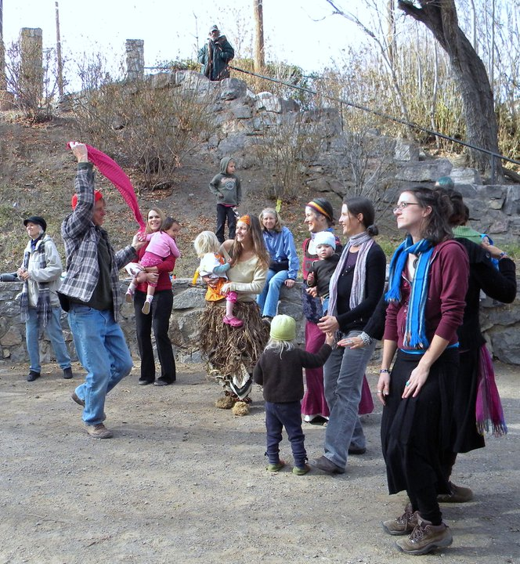

Live, rockin’ traditional music by local group:Gila Circle Way West African Drumming Ensemble
A dress-up, family-friendly, “African Squaredance”gathering in the Big Ditch Park, just below the SC Food Co-op

We encourage folks to come on down before the Women’s day Parade, make up whatever kind of costume you can think of (or don’t), and get out and dance in a village environment. Traditional rhythms of West Africa, each with its own significance for various members or elements of the community, will provide loose formats for how everyone can interact in specific thematic dances (or dance in whatever way you like!) ~ FREE ~
---------------------------------------------------------------------------------------------------------------------------------
Who are we?
The Gila Circle Way Project is run by Andrew Dahl-Bredine and Lexa Jobe, longtime local residents of the Silver City/ Gila area. We currently live in Silver City at 1104 W. 7th St, and host some of our programs there. Most of our programs are currently led by Andrew and/or regular contributor Doug Simons, who lives in Gila. We are always looking for more ways to serve our community and help deepen all of our connection to the natural world, and to each-other. We’d love to hear your feedback and ideas. Feel free to email: andrew21@wildmail.com, or call (575)519-9232. Thanks for participating!
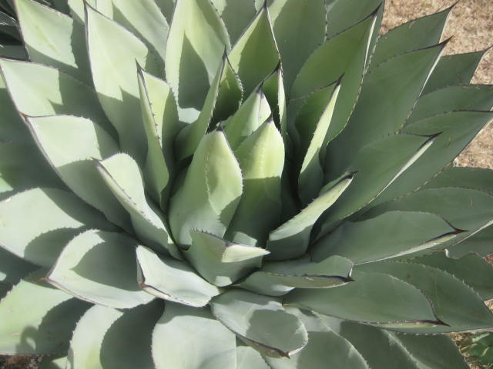

Words of Wisdom:
“I looked at the Okanagan decision-making process in its traditional sense….when we approach the decision-making process, one component is reserved for the land…we have people who are called “land speakers”. We have a word for it in our language. I was fortunate in that I was trained and brought up as a land speaker in my community…we have different people, trained as part of the family system, to be speakers for the children, for the land, for the mothers, for the Elders, for the medicine people, for the land, for the water -- for all these different components that make up our existence.
My part has been to be trained by my Elders to think about the land and to speak about the land…each time a decision is made, even the smallest decision, my responsibility is to stand up and ask, How will it impact the land? How is it going to impact our food? How is going to impact our water? How is going to impact my children, my grandchildren, my great-grandchildren, what’s the land going to look like in their time? So in that process of en’owkinwiwx, there’s a built-in principle in terms of how we interact…Someone has to ask those questions. That’s their responsibility.
When we include the perspective of land and we include the perspective of human relationship, one of the things that happens is that community changes. People in the community change. The realization that people and community are there to sustain you creates the most secure feeling in the world.”

- Excepts from An Okanagan Worldview of Society by Jeanette Armstrong from Original Instructions: Indigenous Teachings for a sustainable Future edited by Melissa K Nelson 2008 Bear & Company in collaboration with Bioneers

“We can be ethical only in relation to something we can see feel, understand, love, or otherwise have faith in. Perhaps the most serious obstacle impeding the evolution of a land ethic is the fact that our educational and economic system is headed away from, rather than toward, an intense consciousness of land. Your true modern is separated from the land by many middlemen, and by innumerable physical gadgets. He has no vital relation to it; to him it is the space between cities on which crops grow…The land is something he has outgrown.

One of the requisites for an ecological comprehension of land is an understanding of ecology, and this is by no means co-extensive with education.” - Aldo Leopold



